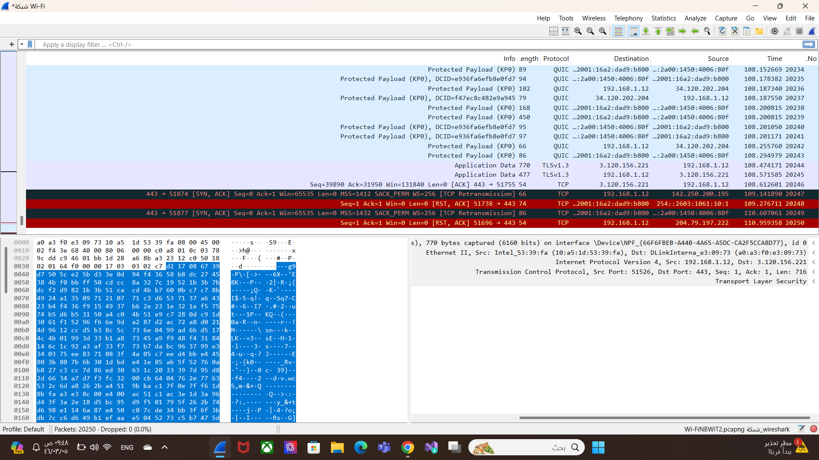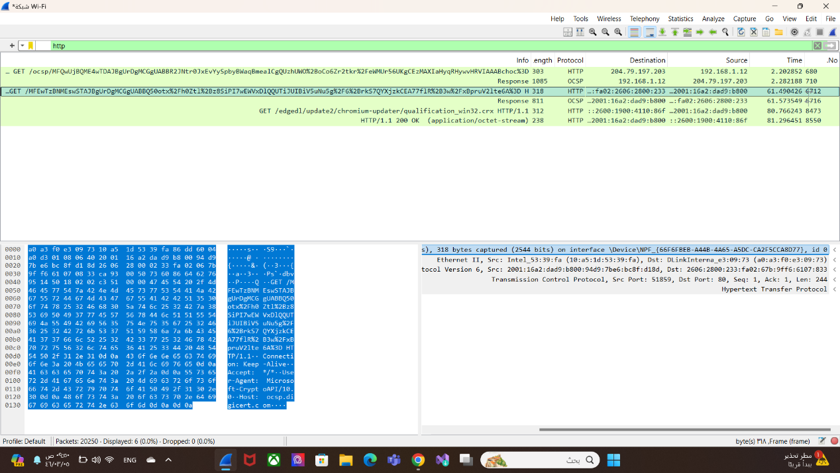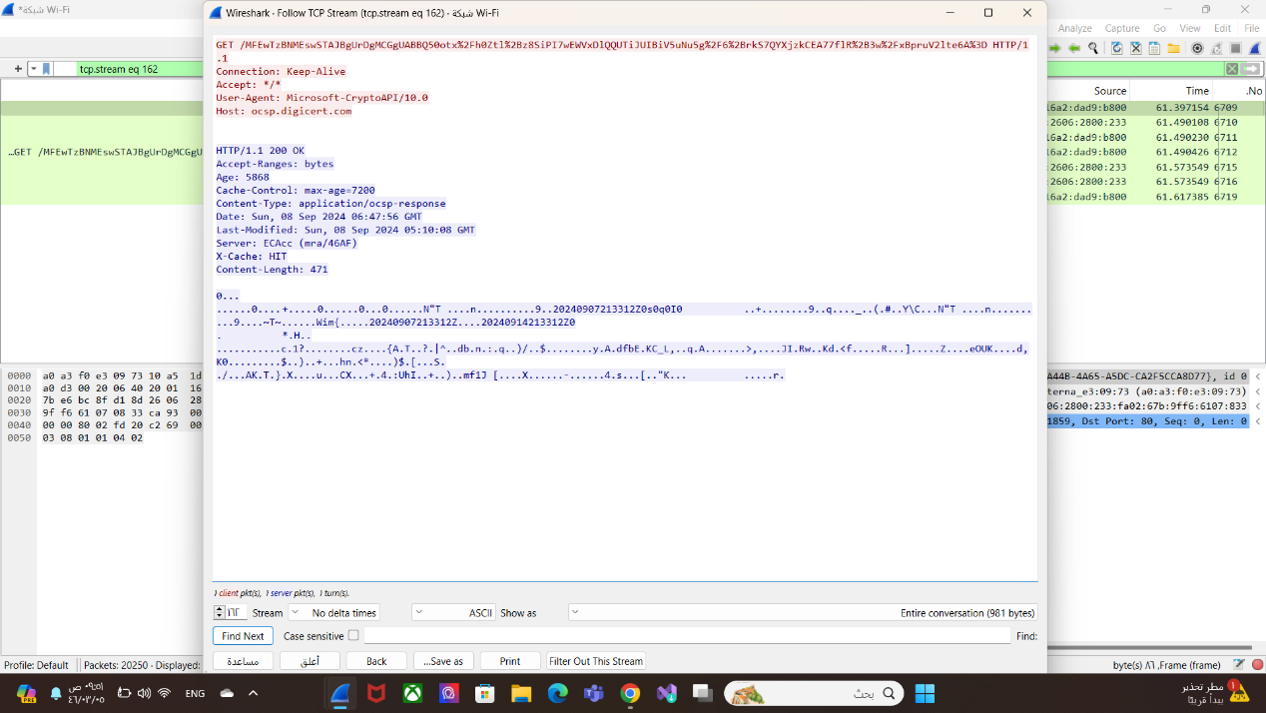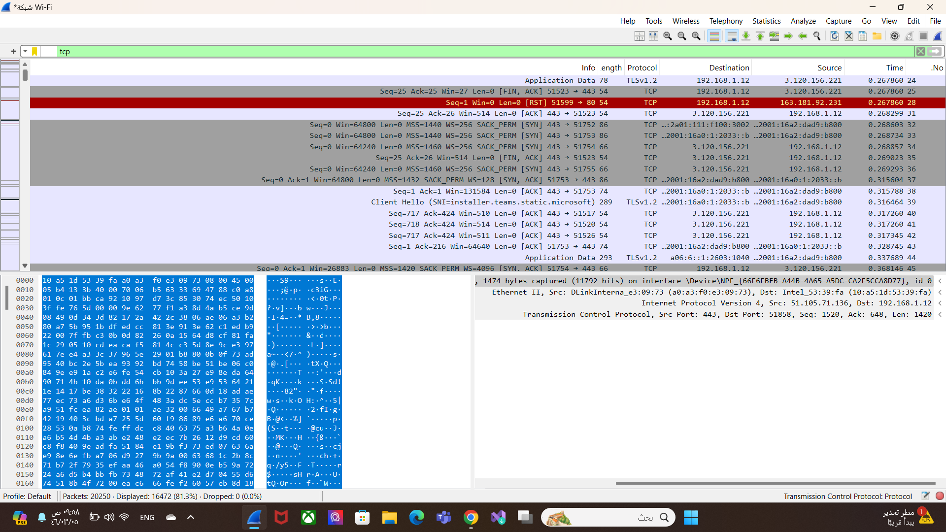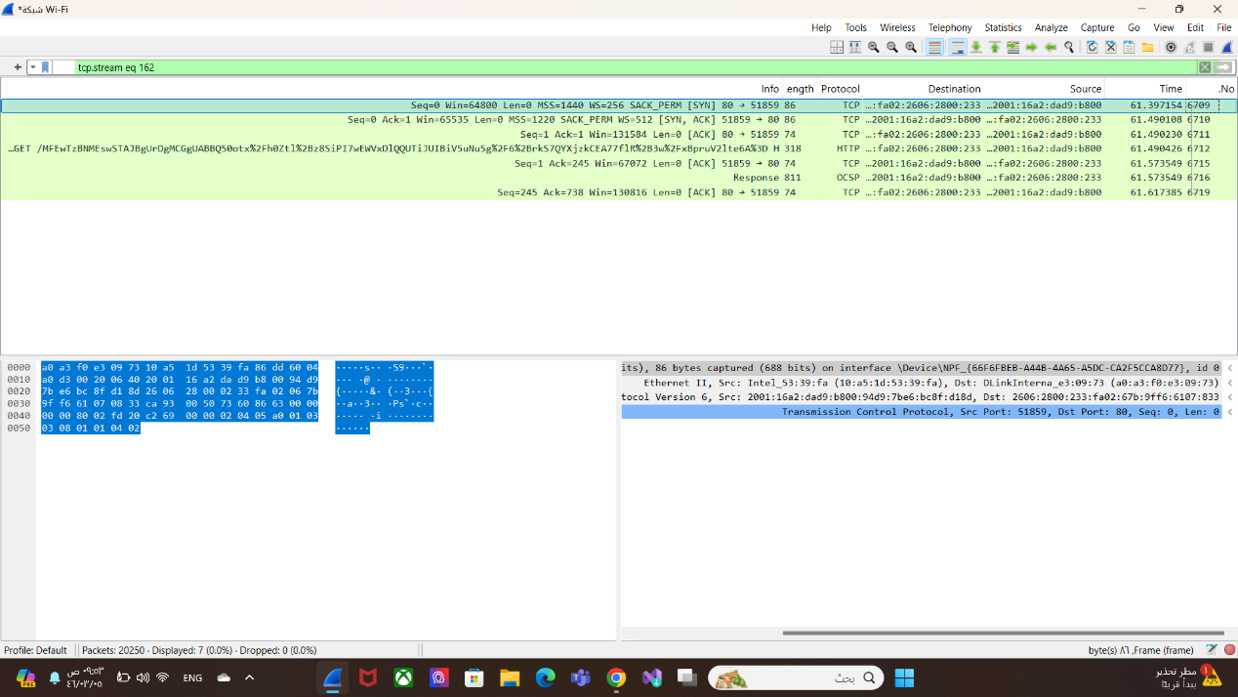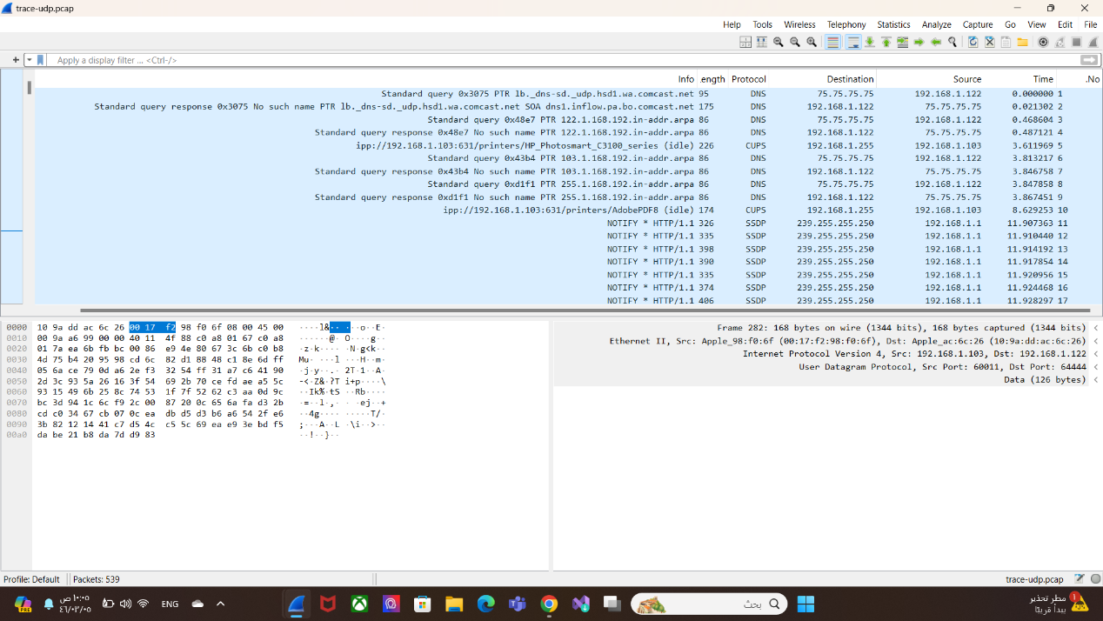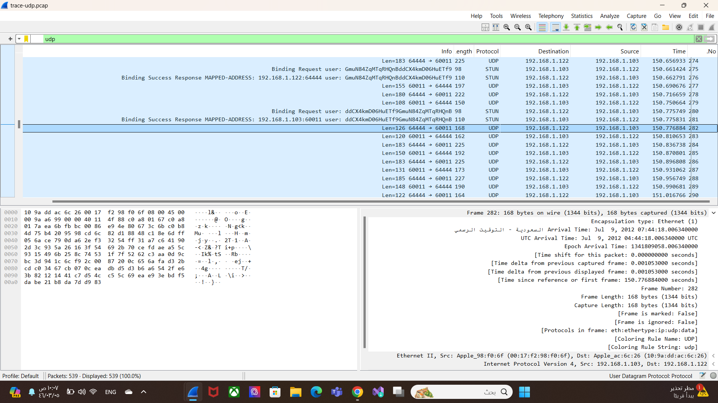

|  |  |  |
| --- | --- | --- |
| **Reasons** | **TCP or UDP** |  |
| **TCP:** It provides mechanisms to ensure data delivery and retransmits lost data if necessary.  **UDP**: Data is sent without guarantees of delivery or order. | **TCP**: Reliable and requires connection establishment before data transfer.  **UDP**: Unreliable and does not require connection establishment. | **Reliability and Connection**  **Establishment** |
| **TCP**: through mechanisms for error checking and retransmission.  **UDP**: Data may arrive missing or out of order. | **TCP**: Ensures data integrity and ordering.  **UDP**: Does not guarantee data integrity or order. | **Data Integrity and Ordering** |
| **UDP** | **TCP** |  |
| Online gaming, video streaming, DNS lookups | File transfer, email, web browsing | **Use cases** |
| Offers a connectionless, lightweight communication method with no guarantees of delivery, order, or error correction. It has lower latency and overhead, making it ideal for real-time applications like video streaming, online gaming, and VoIP, where speed is more critical than reliability. | Provides reliable, connection-oriented communication. It ensures data integrity and order, handles retransmissions, and uses flow and congestion control. This makes it suitable for applications where reliability is crucial, such as web browsing and email, but introduces overhead and latency due to its connection setup and error-checking mechanisms. | **Performance** |